**Project Design Phase-II**

**Technology Stack (Architecture & Stack)**

|  |  |
| --- | --- |
| Date | 03October 2022 |
| Team ID | PNT2022TMID07522 |
| Project Name | Project –Real Time River Water Quality Monitoring and Control System |
| Maximum Marks | 4 Marks |

**Technical Architecture:**

Bluemix Simulator

Open Weather API

Farmer

**input**

**Sensor Data**

Node Red

IBM Cloud Platform

**output**

comments

Internet Gateway

Python Script to receive comments

**Motor**

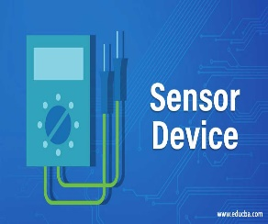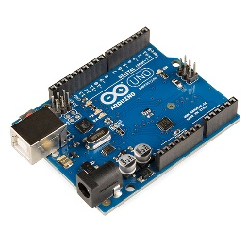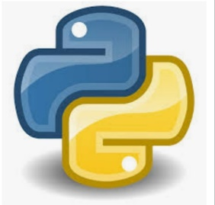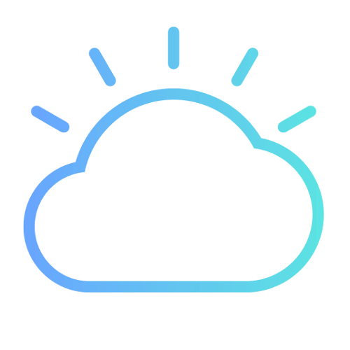

**RIVER SENSORS ARDUINO PYTHON IBM CLOUD**

 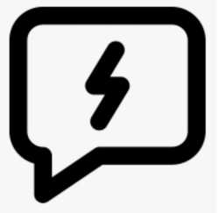

**AUTHORITIES WEB UI MOBILE APP FAST SMS**

**Table-1 : Components & Technologies:**

|  |  |  |  |
| --- | --- | --- | --- |
| **S.No** | **Component** | **Description** | **Technology** |
| 1. | Received data from sensors | The information gathered from the sensor units installed along rivers | ESP32 wifi module |
| 2. | Web interface | The gathered information was presented visually | HTML,CSS, javascript |
| 3. | database | Datatype | MySQL |
| 4. | Cloud database | Cloud database service | IBM cloud |
| 5. | Data storage | Storage needs for files | IBM Block storage |

**Table-2: Application Characteristics:**

|  |  |  |  |
| --- | --- | --- | --- |
| **S.No** | **Characteristics** | **Description** | **Technology** |
| 1. | PH level monitoring | By putting sensors in rivers, it is possible to check the PH level of the water there. | PH-sensor |
| 2. | Temperature monitoring | You can check the temperature of river water | Temperature sensor |
| 3. | Pollution monitoring | It is possible to check the purity and clarity of river water | Conductive sensor |